Data Representation: Understanding different kinds of files and filesizes.
Text
- How many bits of data is used to store each character in a text file eg a .txt file?
- What is the name of a common system used to encode characters on your keyboard into binary?
- How many bytes of information would be required to store this message: Happy Birthday!! in a .txt file

Images
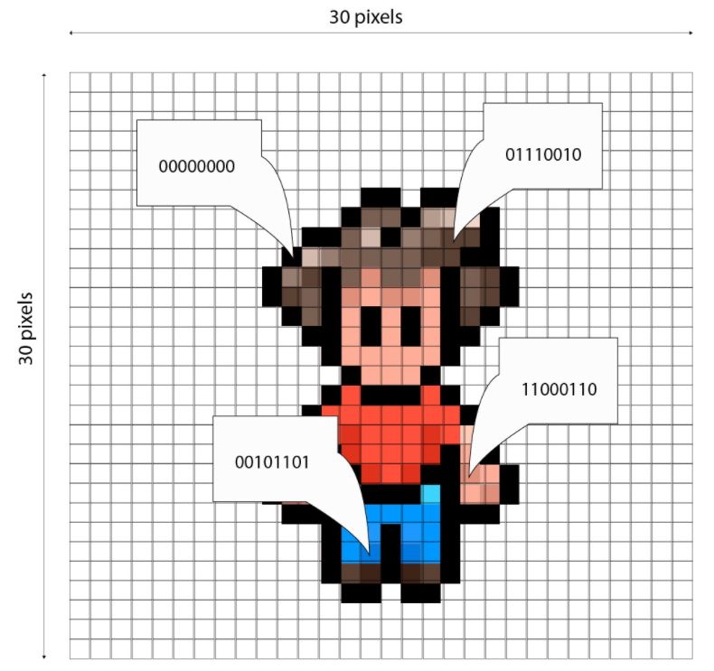
- What is the colour depth of this image?
- How many possible colours is it possible to create using this colour depth?
- Can you calculate the total number of bits (ie the filesize) for this image? What is it?
- Convert your answer from question 3 into Bytes.
- Convert your answer from question 4 in to Kilobytes.
Sound
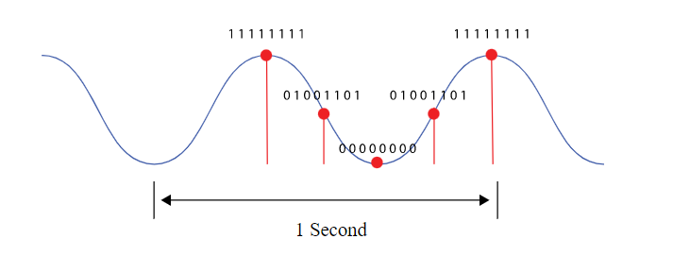
- What is the bit depth used when converting the analogue data into digital data?
- How many samples per second are used in the above image?
- Can you calculate the total number of bits (ie the filesize) for the above example?
- What if the file was 10 seconds long? If the bit depth doesn’t change and the samples per second doesn’t change, what is the new filesize?

Challenge
An image file has a filesize of 76 bytes.
Another file has a filesize of 52 bytes.
Convert these numbers into binary:
76 | 52

Binary Addition
Using your knowledge of binary addition, add the 2 binary numbers together to create the total filesize in binary:
2s complement
Using your knowledge of 2s Complement can you figure out how to calculate the difference between the two files’ filesize (ie the answer in denary is 76-52 = 24)
Show your working here:

